# DAD 220 Database Documentation Template

Complete these steps as you work through the directions for Project One. Replace the bracketed text with your screenshots and brief explanations of the work they capture. Each screenshot and its explanation should be sized to approximately one quarter of the page, with the description written below the screenshot. Follow these rules for each of the prompts and questions below. Review the example document located in the Project One Supporting Materials for assistance.

## Step One: Create a Database

1. Navigate to your online integrated development environment (IDE). Here, you will need to write the proper SQL commands in command line to create tables that demonstrate relationships based on the entity relationship diagram. List and record the SQL commands that you used to complete this step here:

[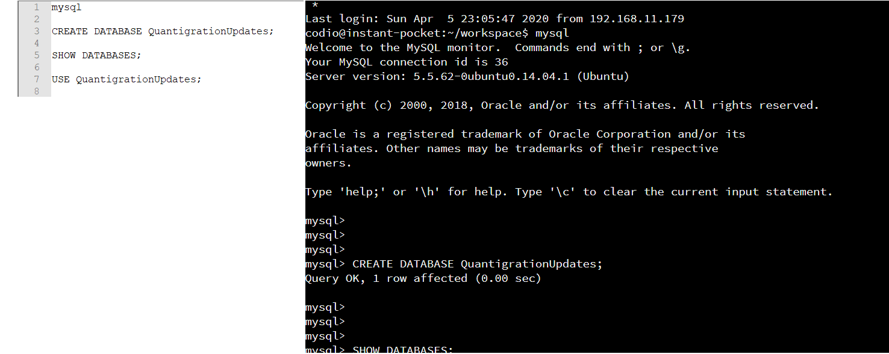I used mysql to enter into SQL to create a database and tables.]

1. Create a database schema called *QuantigrationUpdates*. List out the database name. Provide the SQL commands you ran against MySQL to successfully complete this in your answer:

[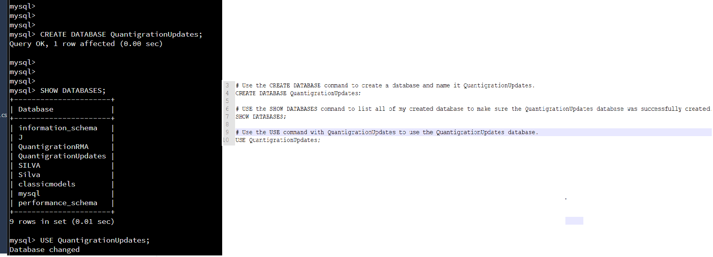]

1. Using the ERD as a reference, **create the following tables with the appropriate attributes and keys**:
   1. A table named **customers** in the *QuantigrationUpdates* database as defined on the project ERD. Provide the SQL commands you ran against MySQL to complete this successfully in your answer:

[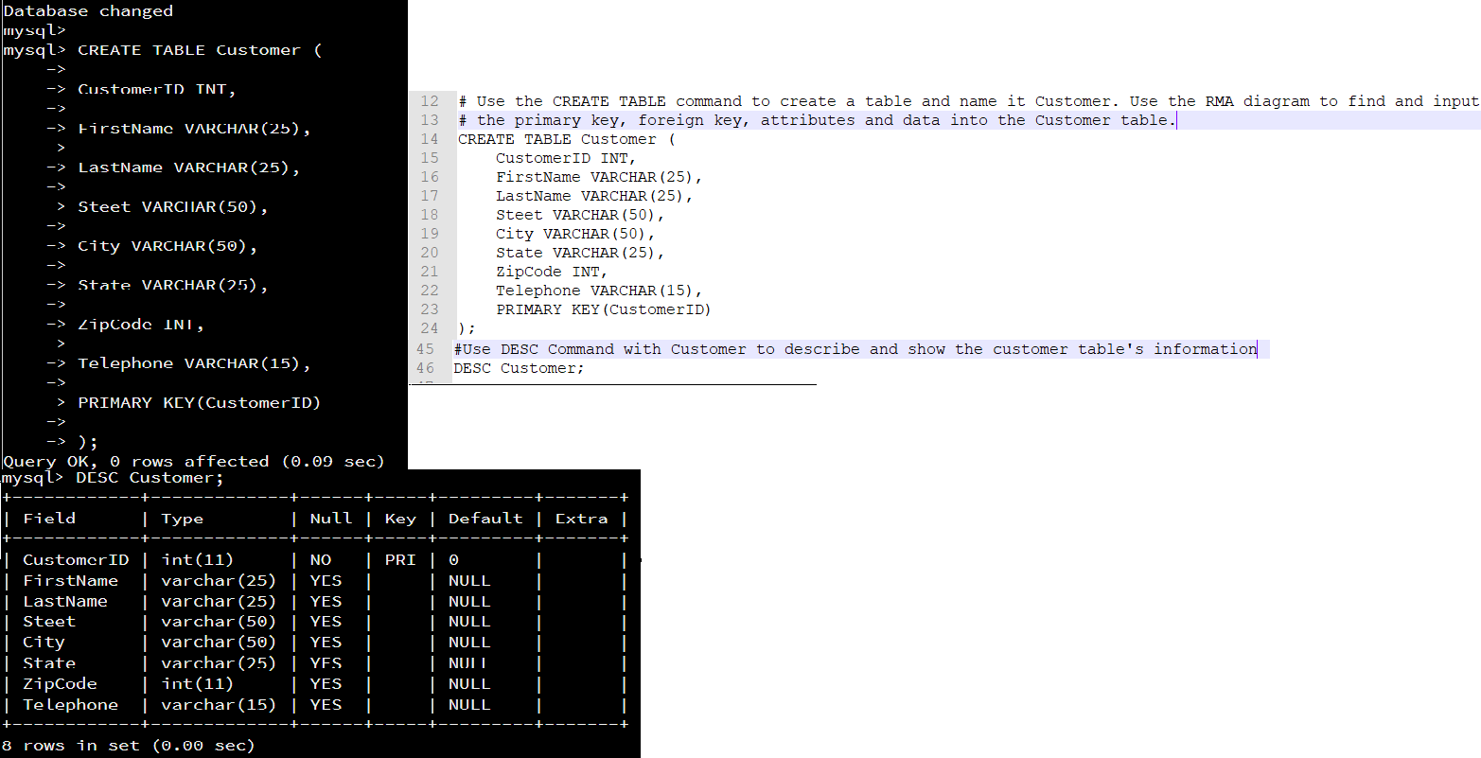]

* 1. A table named **orders** in the *QuantigrationUpdates* database as defined on the project ERD. Provide the SQL commands you ran against MySQL to complete this successfully in your answer:

[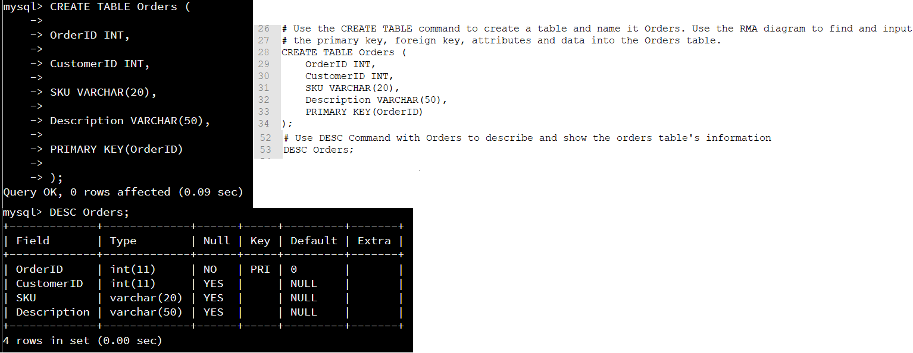]

* 1. A table named **rma** in the *QuantigrationUpdates* database as defined on the project ERD. Provide the SQL commands you ran against MySQL to complete this successfully in your answer:

[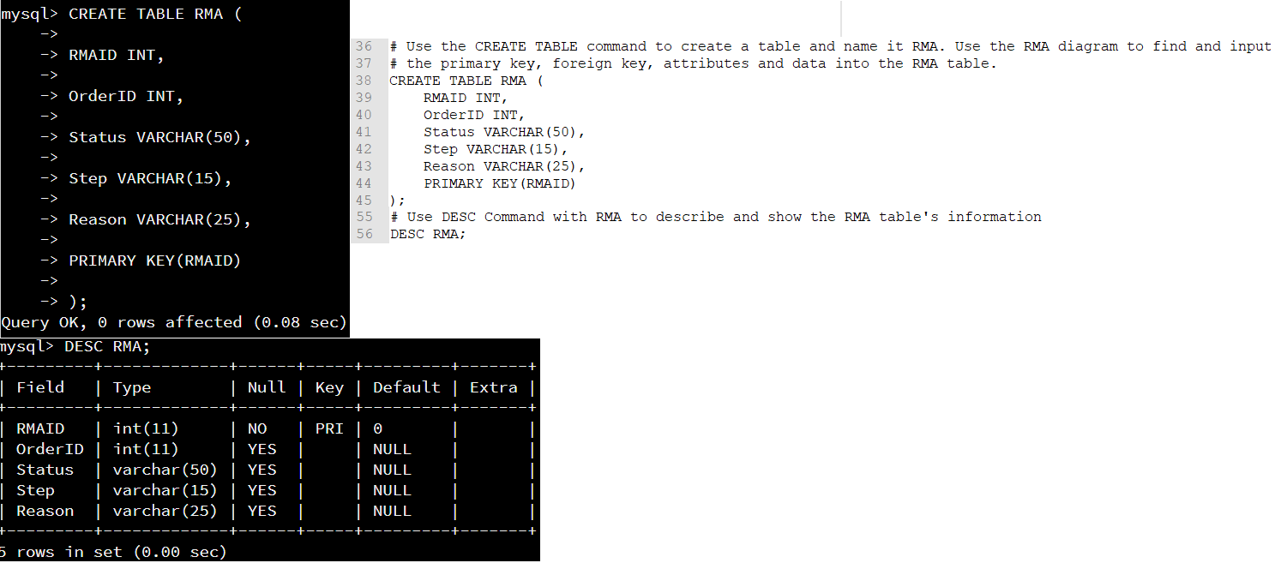]

1. **Update your existing table** from “Customer” to “Collaborator” using SQL based on this change in requirements. Provide the SQL commands you ran against MySQL to complete this successfully in your answer:

[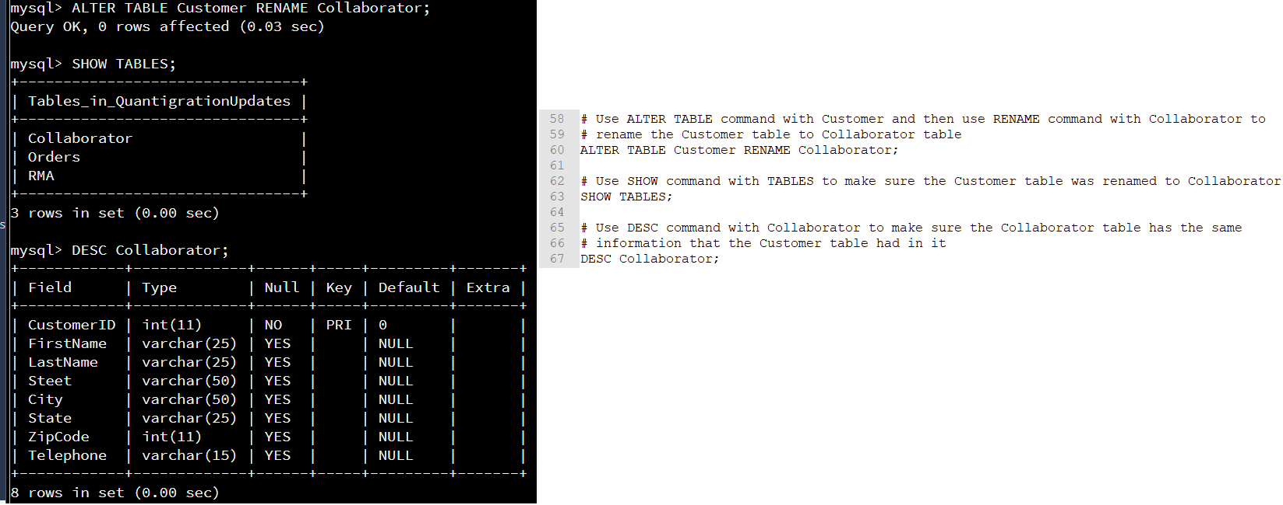]

## Step Two: Load and Query the Data

1. **Import the data from each file into tables**.
   * Use the *QuantigrationUpdates* database, the three tables you created, and the three CSV files preloaded into Codio.
   * Use the import utility of your database program to load the data from each file into the table of the same name. You will perform this step three times, once for each table.
2. **Write basic queries against imported tables to organize and analyze targeted data.** For each query, replace the bracketed text with a screenshot of the query and its output. You should also include a brief, 1- to 3-sentence description of the output.
   * Write an SQL query that returns the count of orders for customers located only in the city of Framingham, Massachusetts.
     1. How many records were returned?

[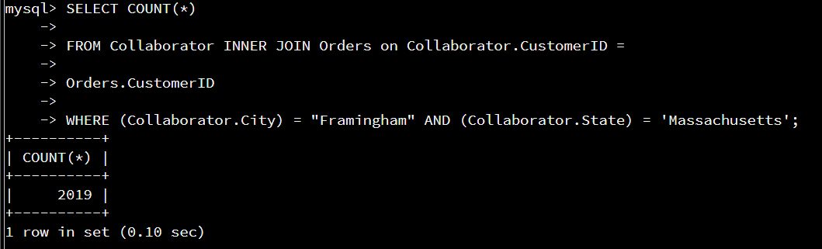]

The output showed the company had 2,019 orders from customers located in the city of Framingham, Massachusetts. The database counted the amount of orders with the use of the SELECT COUNT(*) command. The information was gathered from both the Orders and Collaborator tables within the database.

* + Write an SQL query to select all of the customers located in the state of Massachusetts.
    1. Use a WHERE clause to limit the number of records in the customers table to only those who are located in Massachusetts.
    2. Record an answer to the following question: How many records were returned?

[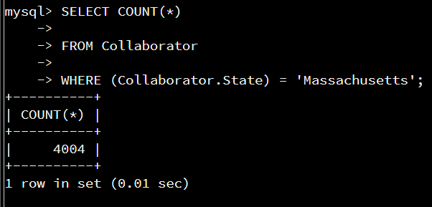]

The output showed the company had 4,004 customers or collaborators from the State of Massachusetts. The database counted the amount of customers or collaborators with the use of the SELECT COUNT(*) command. The information was gathered from Collaborator table within the database.

* + Write a SQL query to insert four new records into the orders and customers tables using the following data:
    1. Customers Table

|  |  |  |  |  |  |  |  |
| --- | --- | --- | --- | --- | --- | --- | --- |
| **CustomerID** | **FirstName** | **LastName** | **StreetAddress** | **City** | **State** | **ZipCode** | **Telephone** |
| 100004 | Luke | Skywalker | 15 Maiden Lane | New York | NY | 10222 | 212-555-1234 |
| 100005 | Winston | Smith | 123 Sycamore Street | Greensboro | NC | 27401 | 919-555-6623 |
| 100006 | MaryAnne | Jenkins | 1 Coconut Way | Jupiter | FL | 33458 | 321-555-8907 |
| 100007 | Janet | Williams | 55 Redondo Beach Blvd | Torrence | CA | 90501 | 310-555-5678 |

[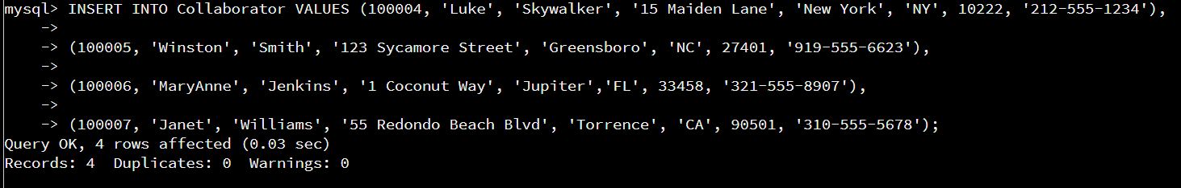]

The output showed 4 rows were affected in the Collaborator table by adding the 4 new records which are shown above. The Collaborator table was the former Customer table, but the name was altered in Step #1 of this project. The additional data was added with the data from the .csv file that I loaded into the Collaborator table.

* + 1. Orders Table

|  |  |  |  |
| --- | --- | --- | --- |
| **OrderID** | **CustomerID** | **SKU** | **Description** |
| 1204305 | 100004 | ADV-24-10C | Advanced Switch 10GigE Copper 24 port |
| 1204306 | 100005 | ADV-48-10F | Advanced Switch 10 GigE Copper/Fiber 44 port copper 4 port fiber |
| 1204307 | 100006 | ENT-24-10F | Enterprise Switch 10GigE SFP+ 24 Port |
| 1204308 | 100007 | ENT-48-10F | Enterprise Switch 10GigE SFP+ 48 port |

[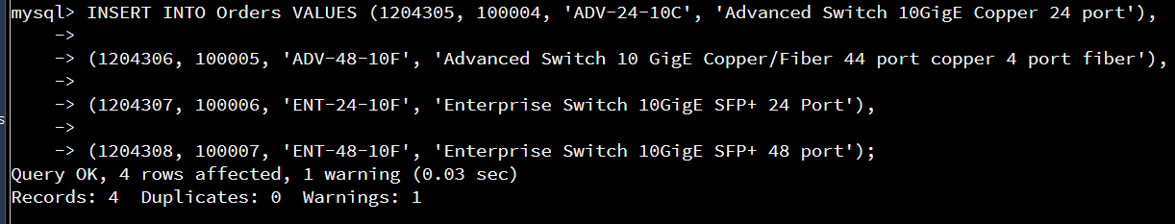]

The output showed 4 rows were affected in the Orders table by adding the 4 new records which are shown above. The additional data was added with the data from the .csv file that I loaded into the Orders table.

* + In the customers table, perform a query to count all records where the city is Woonsocket, Rhode Island.
    1. How many records are in the customers table where the field “city” equals “Woonsocket”?

[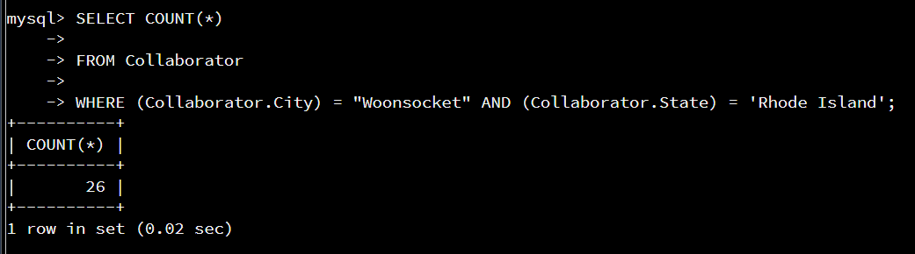]

The output showed the company had 26 customers or collaborators located in the city of Woonsocket, Rhode Island. The database counted the amount of orders with the use of the SELECT COUNT(*) command. The information was gathered from Collaborator table within the database.

* + In the rma database, update a customer’s records.
    1. Write an SQL statement to select the current fields of *status* and *step* for the record in the *rma* table with an *orderid* value of “5175.”
       1. What are the current status and step?

[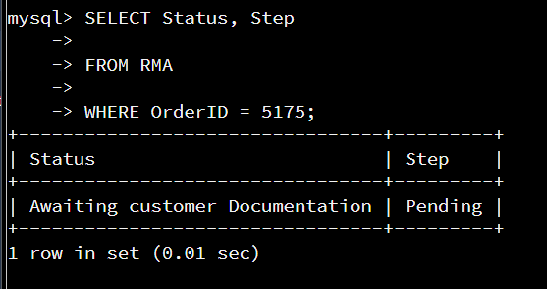]

The commands first made the database search for data from the RMA table where the OrderID was 5175 and then show the status and step for OrderID 5175. One row was affected by this command from the RMA table. The status and step were displayed in the photograph above.

* + 1. Write an SQL statement to update the *status* and *step* for the *orderid*, 5175 to *status* = “Complete” and *step* = “Credit Customer Account.”
       1. What are the updated *status* and *step* values for this record?

[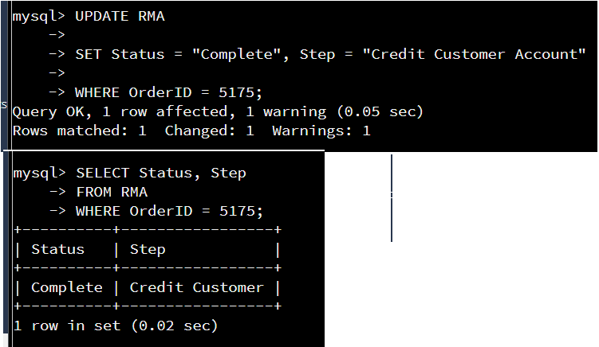]

The commands first made the database update the data from the RMA table where the OrderID was 5175 and then set the status and step for OrderID 5175. One row was affected by this command from the RMA table. The status and step were updated and displayed in the photograph above.

* + Delete rma records.
    1. Write an SQL statement to delete all records with a reason of “Rejected.”
       1. How many records were deleted?

[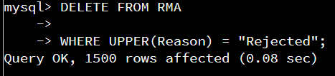]

The commands deleted any records from the RMA table where reason = Rejected. The photograph displayed above showed 1,500 records were deleted from the RMA table.

1. **Create an output file of the required query results.** Write an SQL statement to list the contents of the *orders* table and send the output to a file that has a .csv extension.

[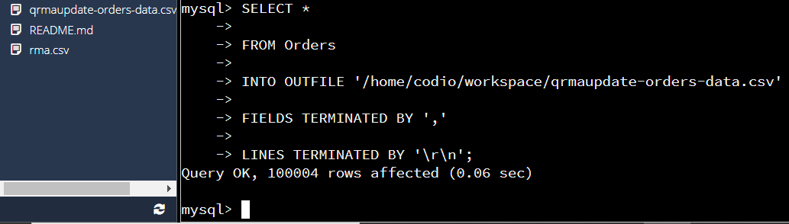]

The command created an outfile in the codio workspace. I named the .csv file as qrmaupdate-orders-data. The top left corner of the above photograph showed the qrmaupdate-orders-data.csv file was successfully created into the codio workspace.